# DAD 220 Database Documentation Template

Complete these steps as you work through the directions for Project One. Replace the bracketed text with your screenshots and brief explanations of the work they capture. Each screenshot and its explanation should be sized to approximately one quarter of the page, with the description written below the screenshot. Follow these rules for each of the prompts and questions below. Review the example document located in the Project One Supporting Materials for assistance.

## Step One: Create a Database

1. A screen shot of a computer

   Description automatically generatedNavigate to your online integrated development environment (IDE). List and record the SQL commands that you used to complete this step here:

Code Used: show databases;

This screenshot shows the command “show databases” to show I am in mysql in the right location and ready to create the QuantigrationUpdates database.

1. A screenshot of a computer

   Description automatically generatedCreate a database schema called QuantigrationUpdates. List out the database name. Provide the SQL commands you ran against MySQL to successfully complete this in your answer:

Code used: “CREATE DATABASE QuantigrationUpdates” and “show databases”

This screenshot shows the commands “CREATE DATABASE QuantigrationUpdates” and “show databases” to show that a database was created and the command show databases is used to show what databases are available with QuantigrationUpdates now available to use.

1. Using the entity relationship diagram (ERD) as a reference, create the following tables with the appropriate attributes and keys:
   1. A black screen with white text

      Description automatically generatedA screen shot of a computer screen

      Description automatically generatedA table named **Customers** in the QuantigrationUpdates database, as defined on the project ERD. Provide the SQL commands you ran against MySQL to complete this successfully in your answer:

Code used: CREATE TABLE Customers (

CustomerID INT,

FirstName VARCHAR(25),

LastName VARCHAR(25),

Street VARCHAR(50),

City VARCHAR(50),

State VARCHAR(25),

ZipCode INT,

Telephone VARCHAR(15),

PRIMARY KEY (CustomerID)

);

This screenshot shows the command used to create a tabe called Customers in the QuantigrationUpdates database.

* 1. A screenshot of a computer program

     Description automatically generatedA screen shot of a computer

     Description automatically generatedA table named **Orders** in the QuantigrationUpdates database, as defined on the project ERD. Provide the SQL commands you ran against MySQL to complete this successfully in your answer:

Code used: CREATE TABLE Orders (

OrderID INT,

CustomerID INT,

SKU VARCHAR(20),

Description VARCHAR(50),

PRIMARY KEY (OrderID),

FOREIGN KEY (CustomerID) REFERENCES Customers(CustomerID));

This screenshot shows the command that was used to create the Orders table in the QuantigrationUpdates database.

* 1. A screen shot of a computer program

     Description automatically generatedA computer screen shot of a black screen

     Description automatically generatedA table named **RMA** in the QuantigrationUpdates database, as defined on the project ERD. Provide the SQL commands you ran against MySQL to complete this successfully in your answer:

Code used: CREATE TABLE RMA (

RMAID INT,

OrderID INT,

Step VARCHAR(50),

Status VARCHAR(15),

Reason VARCHAR(15),

PRIMARY KEY (RMAID),

FOREIGN KEY (OrderID) REFERENCES Orders(OrderID)

);

This is a screenshot of the command that created a table called “RMA” in the QuantigrationUpdates database.

## Step Two: Load and Query the Data

1. **Import the data from each file into tables.** 
   * Use the QuantigrationUpdates database, the three tables you created, and the three CSV files preloaded into Codio.
   * A screenshot of a computer code

     Description automatically generatedUse the import utility of your database program to load the data from each file into the table of the same name. You will perform this step three times, once for each table.

Code used: LOAD DATA INFILE '/home/codio/workspace/customers.csv'

INTO TABLE Customers

FIELDS TERMINATED BY ','

LINES TERMINATED BY '\n';

LOAD DATA INFILE '/home/codio/workspace/orders.csv'

INTO TABLE Orders

FIELDS TERMINATED BY ','

LINES TERMINATED BY '\n';

LOAD DATA INFILE '/home/codio/workspace/rma.csv'

INTO TABLE RMA

FIELDS TERMINATED BY ','

LINES TERMINATED BY '\n';

This command was used to import data in the three tables called Customers, Orders, and RMA.

1. **Write basic queries against imported tables to organize and analyze targeted data.** For each query, replace the bracketed text with a screenshot of the query and its output. You should also include a 1- to 3-sentence description of the output.
   * Write an SQL query that returns the **count** of orders for customers located only in the city of Framingham, Massachusetts.
     1. A black background with white text

        Description automatically generatedHow many records were returned?

Code used: select Count(*) from Customers where State = 'Massachusetts' and City = 'Framingham';

This screenshot shows the command above being used to return the count for records of orders from Framingham, Massachusetts.

* + Write an SQL query to **select all** of the Customers located in the state of Massachusetts.
    1. Use a WHERE clause to limit the number of records in the Customers table to only those who are located in Massachusetts.
    2. A black screen with white text

       Description automatically generatedRecord an answer to the following question: How many records were returned?

Code used: select Count(*) from Customers

-> WHERE State = 'Massachusetts';

This screenshot shows the select command being used with a where clause to return records of Customers located only in Massachusetts.

* + Write a SQL query to insert four new records into the Orders and Customers tables using the following data:

**Customers Table**

| **CustomerID** | **FirstName** | **LastName** | **StreetAddress** | **City** | **State** | **ZipCode** | **Telephone** |
| --- | --- | --- | --- | --- | --- | --- | --- |
| 100004 | Luke | Skywalker | 15 Maiden Lane | New York | NY | 10222 | 212-555-1234 |
| 100005 | Winston | Smith | 123 Sycamore Street | Greensboro | NC | 27401 | 919-555-6623 |
| 100006 | MaryAnne | Jenkins | 1 Coconut Way | Jupiter | FL | 33458 | 321-555-8907 |
| 100007 | Janet | Williams | 55 Redondo Beach Blvd | Torrence | CA | 90501 | 310-555-5678 |

Code used: INSERT INTO Customers(CustomerID, FirstName, LastName, Street, City, State, ZipCode, Telephone)

VALUES

(100004, 'Luke', 'Skywalker', '17 Maiden Lane', 'New York', 'NY', '10222','212-555-1234'),

(100005, 'Winston','Smith','128 Sycamore Street','Greensboro','NC','27401','919-555-6623'),

(100006, 'MaryAnne','Jenkins','2 Coconut Way','Jupiter','FL','33458','321-555-8907'),

(100007, 'Janet','Williams','58 Redondo Beach BLVD','Torrence','CA','90501','310-555-5678');

This is a screen show of the command above adding four new records to the Customers table in the QuantigrationUpdates database.

**Orders Table**

| **OrderID** | **CustomerID** | **SKU** | **Description** |
| --- | --- | --- | --- |
| 1204305 | 100004 | ADV-24-10C | Advanced Switch 10GigE Copper 24 port |
| 1204306 | 100005 | ADV-48-10F | Advanced Switch 10 GigE Copper/Fiber 44 port copper 4 port fiber |
| 1204307 | 100006 | ENT-24-10F | Enterprise Switch 10GigE SFP+ 24 Port |
| 1204308 | 100007 | ENT-48-10F | Enterprise Switch 10GigE SFP+ 48 port |

Code used: INSERT INTO Orders

VALUES

-> (1204305, 100004, 'ADV-24-10C', 'Advanced Switch 10GigE Copper 24 port'),

-> (1204306, 100005, 'ADV-48-10F','Advanced Switch 10 GigE Cpr/Fbr 44 port'),

-> (1204307, 100006, 'ENT-24-10F','Enterprise Switch 10GigE SFP+ 24 Port'),

-> (1204308, 100007, 'ENT-48-10F','Enterprise Switch 10GigE SFP+ 48 port');

This screenshot shows the command used above to add four new records into the Orders table in the QuantigrationUpdates database.

* + In the Customers table, perform a query to count all records where the city is Woonsocket, Rhode Island.
    1. 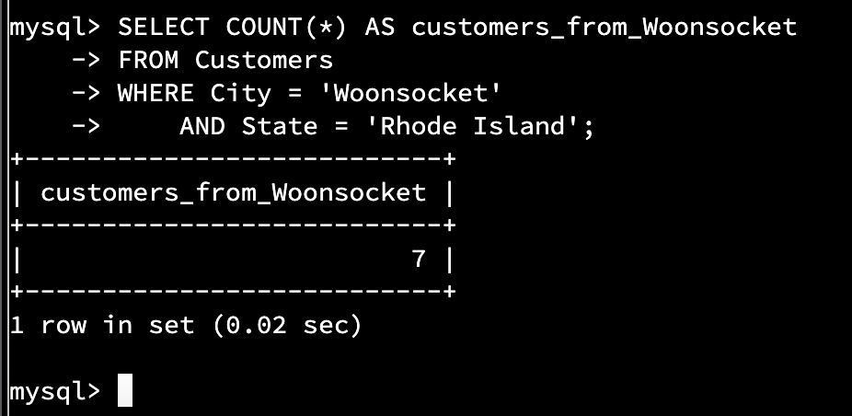How many records are in the Customers table where the field “city” equals “Woonsocket”?

Code used: SELECT COUNT(*) AS customers_from_Woonsocket

-> FROM Customers

-> WHERE City = 'Woonsocket'

-> AND State = 'Rhode Island';

This screenshot is of the command that I used to return the number of customers from Woonsocket Rhode Island.

* + In the RMA database, update a customer’s records.
    1. Write an SQL statement to select the current fields of **status** and **step** for the record in the **RMA** table with an **orderid** value of “5175.”
       1. What are the current status and step?

Code used: SELECT OrderID, Status, Step

-> FROM RMA

-> WHERE OrderID = 5175;

This screenshot shows the command used to view the current status of a customers order in the RMA table.

* + 1. Write an SQL statement to update the **status** and **step** for the **OrderID**, 5175 to **status** = “Complete” and **step** = “Credit Customer Account.”
       1. A screenshot of a computer program

          Description automatically generatedWhat are the updated **status** and **step** values for this record?

Code used: UPDATE RMA

-> SET Status = 'Complete',

-> Step = 'Credit Customer Account.'

-> WHERE OrderID = 5175;

This screenshot shows the command I used to update a customer's order status and step in the RMA table.

* + Delete RMA records.
    1. Write an SQL statement to delete all records with a reason of “Rejected.”
       1. A screenshot of a computer program

          Description automatically generatedHow many records were deleted? 596 records.

Code used: DELETE FROM RMA

-> WHERE Reason = 'Rejected';

This screenshot shows the command I used to delete 596 records from the RMA table where Reason = Rejected.

1. **Update your existing tables** from “Customer” to “Collaborator” using SQL based on this change in requirements. Provide the SQL commands you ran against MySQL to complete this successfully in your answer:
   1. A screenshot of a computer

      Description automatically generatedRename all instances of “Customer” to “Collaborator.”

Code used: RENAME TABLE Customers To Collaborator;

ALTER TABLE Collaborator CHANGE CustomerID

-> CollaboratorID INT;

ALTER TABLE Orders CHANGE CustomerID

-> CollaboratorID INT;

This screenshot shows the commands used to rename the Customers table to Collaborator. Also the command “Alter table” was used to alter the CustomerID to CollaboraterID in both the Customer table and the Order table.

1. A screenshot of a computer

   Description automatically generated**Create an output file of the required query results.** Write an SQL statement to list the contents of the **Orders** table and send the output to a file that has a .csv extension.

Code used: SELECT *

-> FROM Orders

-> INTO OUTFILE '/home/codio/workspace/project_one_merren.csv'

-> FIELDS TERMINATED BY ','

-> LINES TERMINATED BY '\n';

This screenshot shows the commands I used to export the contents of the Order table using a CSV file. This will make it easier to upload the contents anywhere else.